**Array and pointer**

**Objectives:**

1. **To add function ave_data () for example of array and pointer**
2. **To add function stddev () to calculate standard deviation for example of array and pointer**

**a**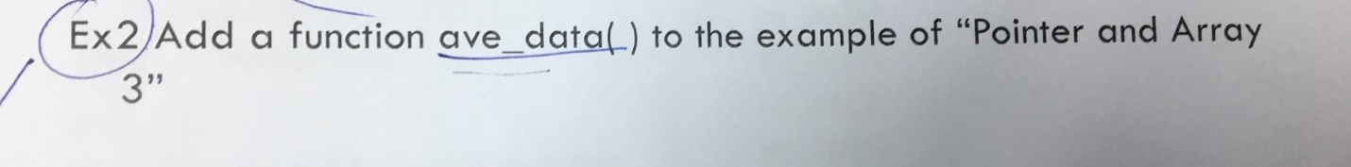

**Code Description**

**//declare directive**

#include<stdio.h>

**//MDATA is a array and size is 100**

#define MDATA 100

**//write functions which use in the code, here “get_data” function and “ave_data”**

**Then, *pointer to data, “n” is the number of input element, its data type is a integer**

int get_data(double *dat, int n);

double ave_data(double *dat, int n);

**//Main function part**

void main(void)

{

**//declare variables n, total, average and x.**

**“x” is array and data type is double also, total and average values are double. X array this case for 100 input elements.**

double x[MDATA];

int n;

double total, average;

**// receive value from user**

printf("Input values:\n");

scanf("%d", &n);

**//calling function to record each value ,from each array to get data.**

get_data(x, n);

**//calling average function**

average = ave_data(x, n);

**//*Show average value which can be long floating number*/**

printf("average = %lf\n", average);

}

**//Part of recording value to array**

int get_data(double*dat, int n)

{

int i;

**//”for” loop from i = 0 to i < n. In each iteration of the loop, the user is asked to enter numbers to calculate the average.**

for (i = 0; i < n; i++)

**// these numbers are stored in the dat[i] array.**

scanf("%lf", &dat[i]);

}

**/*”Ave_data” function use to calculate average, receive 2 input values which are a pointer to array (*dat) and a number of data (n) and return average/\***

double ave_data(double *dat, int n)

{

int i;

double total;

total = 0;

for (i = 0; i < n; i++)

**// the sum of each entered element is computed as “Total”**

total = total + dat[i];

**// Once the “for” loop is completed, the average is calculated and printed on the screen.**

return total / n;

}

**Output**

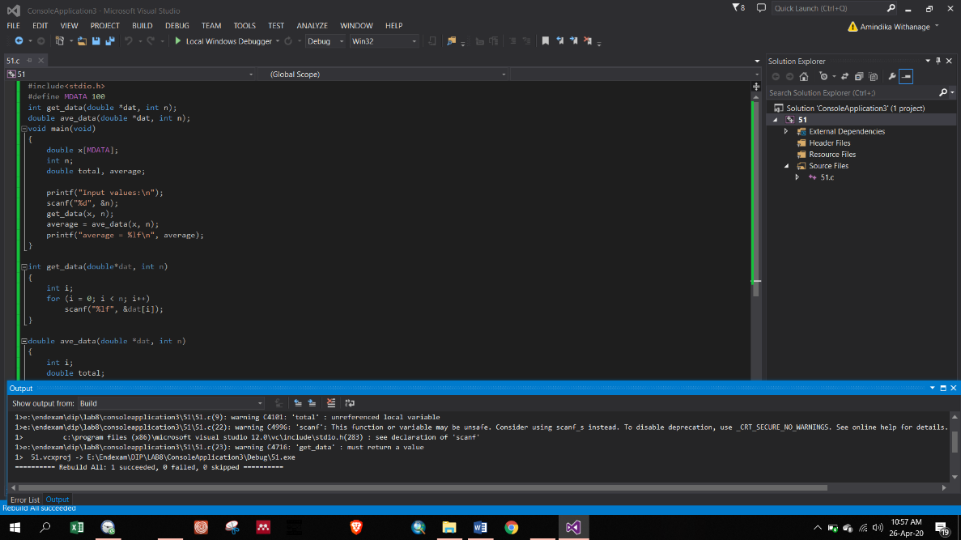Here, the array containing 2 elements is passed to the ave_data() function. The function calculates the average using total and returns it ***(Figure 1).***

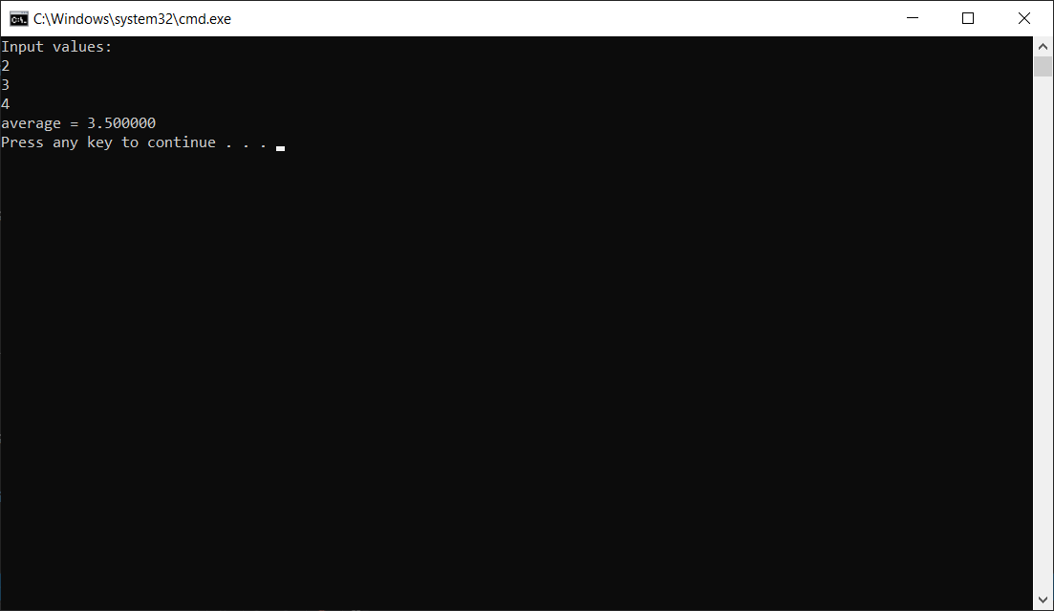

**Figure 1:** Average of input 2 element

**b)**



**Code Description**

**//declare directive including maths**

#include<stdio.h>

#include<math.h>

**//MDATA is a array and size is 100**

#define MDATA 100

**//write functions which use in the code, here “get_data” function and “ave_data”, “std_dev” for standard deviation.**

**Then, *pointer to data, “n” is the number of input element, its data type is a integer .**

int get_data(double *dat, int n);

double avg(double *dat, int n);

double std_dev(double *dat, double average, int n);

**//Main function part**

void main(void)

{

**//declare variables n, total, average, stdv and x.**

**“x” is array and data type is double. Also, total and average and stdv are double. X array this case for 100 input elements.**

double x[MDATA];

int n;

double total, average, stdv;

**// receive value from user**

printf("Input values:\n");

scanf("%d", &n);

**//calling function to record each value ,from each array to get data.**

get_data(x, n);

**//calling average function**

average = avg(x, n);

**//calling standard deviation function**

stdv = std_dev(x,average, n);

**//*Show average value which can be long floating number*/**

printf("Standard Deviation = %lf\n", stdv);

}

**//Part of recording value to array**

int get_data(double*dat, int n)

{

int i;

**//”for” loop from i = 0 to i < n. In each iteration of the loop, the user is asked to enter numbers to calculate the average.**

for (i = 0; i < n; i++)

**// these numbers are stored in the dat[i] array.**

scanf("%lf", &dat[i]);

}

**/*”Ave_data” function use to calculate average, receive 2 input values which are a pointer to array (*dat) and a number of data (n) and return average/\***

double avg(double *dat, int n)

{

int i;

double total;

total = 0;

for (i = 0; i < n; i++)

**// the sum of each entered element is computed as “Total”**

total = total + dat[i];

**// Once the “for” loop is completed, the average is calculated and printed on the screen.**

return total / n;

}

**/*” std_dev” function use to calculate standard deviation of average, receive 3 input values which are a pointer to array (*dat), average and a number of data (n) and return std_dev /\***

double std_dev(double *dat, double average, int n)

{

int i,x;

double total = 0;

for (i = 0; i < n; i++)

**// the sum of each variance is computed as “Total”**

total += (dat[i] - average)*(dat[i] - average);

**// Once the “for” loop is completed, the Standard deviation is calculated and printed on the screen.**

return sqrt(total / n);

}

**Output**

Here, the array containing 10 elements is passed to the std_dev() function. The function calculates the standard deviation using mean and returns it ***(Figure 2).***

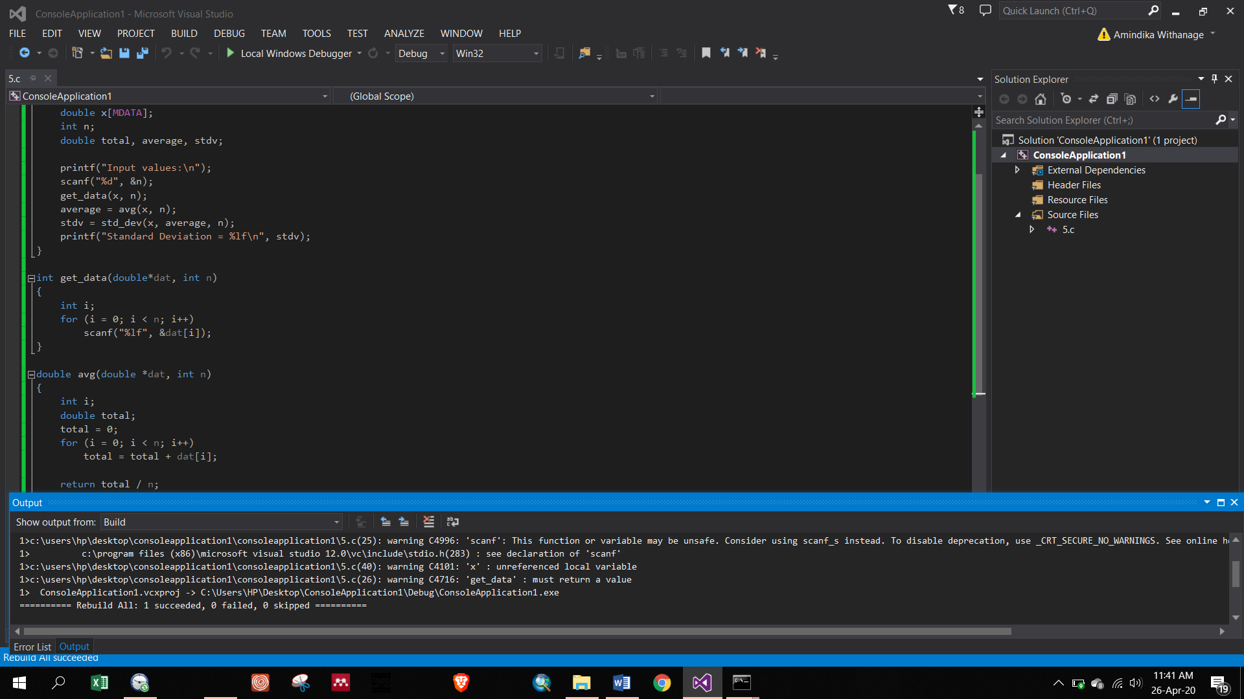

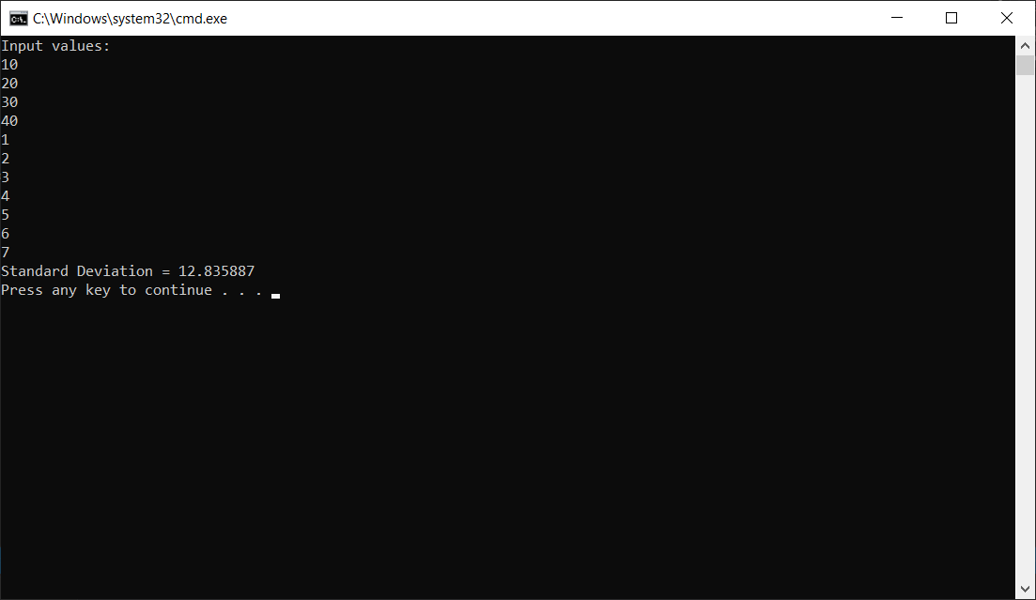

**Figure 2:** standard deviation calculation using 10 elements entered